

**Changsha University of Science and Technology**

School of Computer and Communications Engineering Experiment Course for Python Programming

# Course Name: Python ProgrammingGrade: 2021 Fall Major: Computer Science and Technology

# Student ID: Gj2021009135 Chinese Name: **莫森**

# Name: Munasinghe Munagamage Don Ashan Dinisuru

# Date: 28/03/2024

**(1) Guess commodity prices**

A shopping mall carries out promotion to let customers guess the price of goods. Each lucky audience has five chances. When you enter a price, the system will prompt whether it is high or low. If you don't guess it correctly five times, you won't get the product; If you guess right, take the prize home. This exercise requires the use of Python to implement this quiz program.

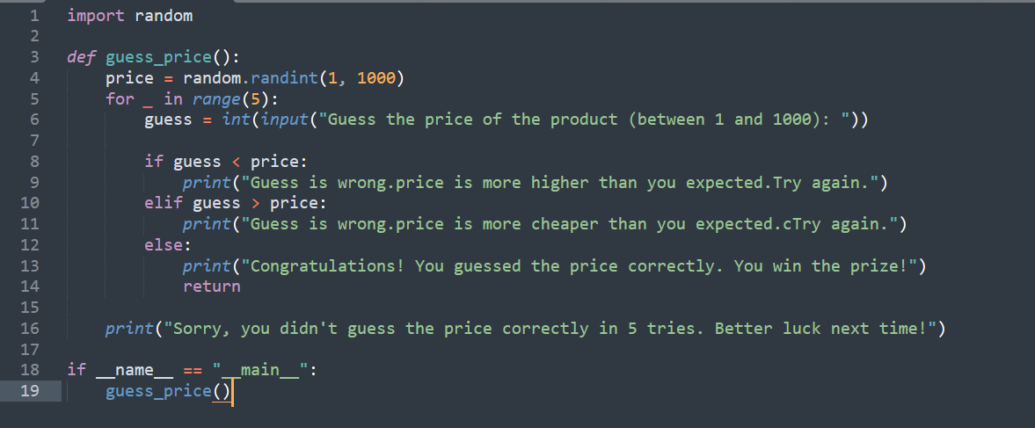

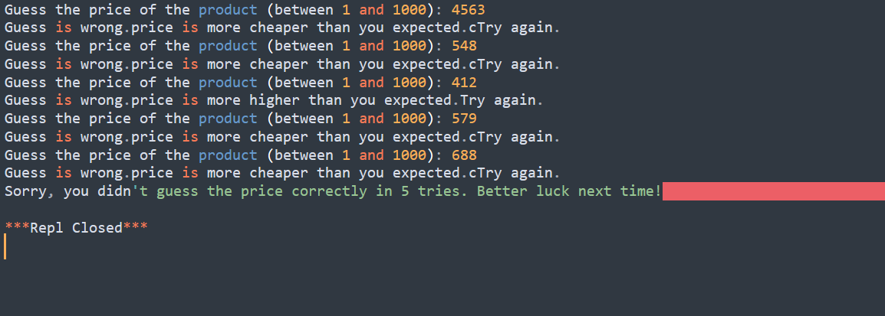

**(2) Output asterisk (*) array**

Use two methods to output 10 lines of asterisks (*), the first line is one asterisk, the second line is two asterisks, and so on, until the tenth line has 10 asterisks.

*

**

***

****

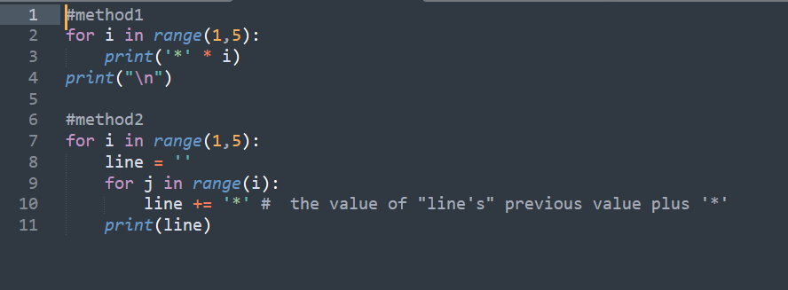

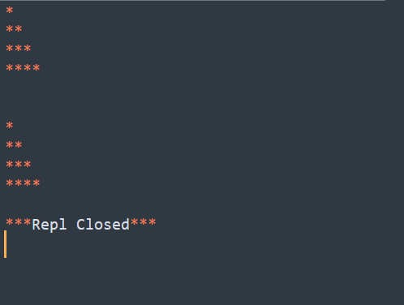

**Addition Programs:**

1. Write a program that generates a list of 20 random integers, and then sorts the elements with even subscripts in descending order, leaving the elements with odd subscripts unchanged.

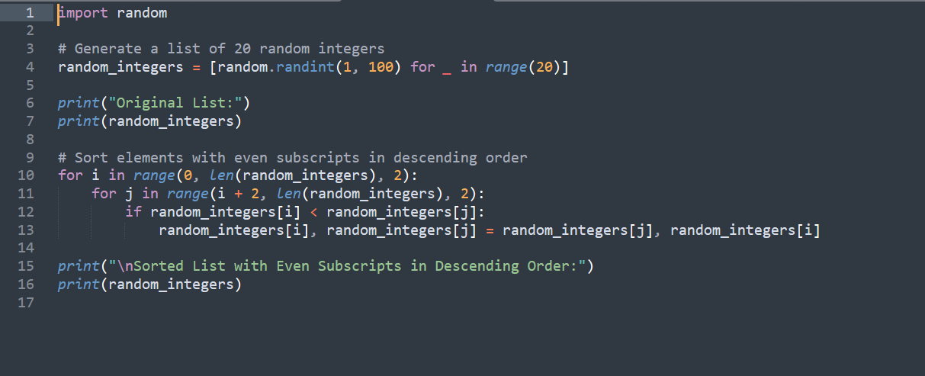

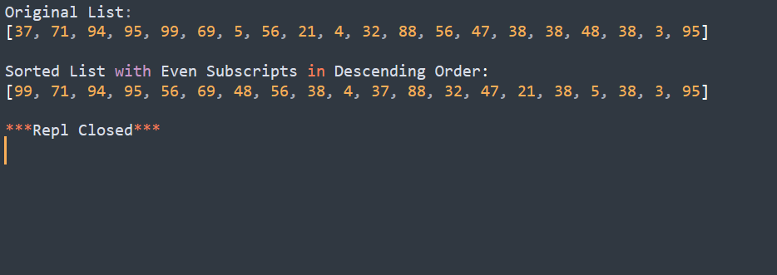

1. Avanti played chess with the king, and the king said that if he lost, he could get whatever Avanti wanted. Avanti said that we need rice. There are 64 small squares on the chessboard. Put 1 grain of rice in the first square, 2 grains of rice in the second square, 4 grains of rice in the third square, and 8 grains of rice in the fourth square. By analogy, the amount of rice in each subsequent grid is twice that of the previous grid, and all 64 grids have been filled. How many grains of rice are needed?

